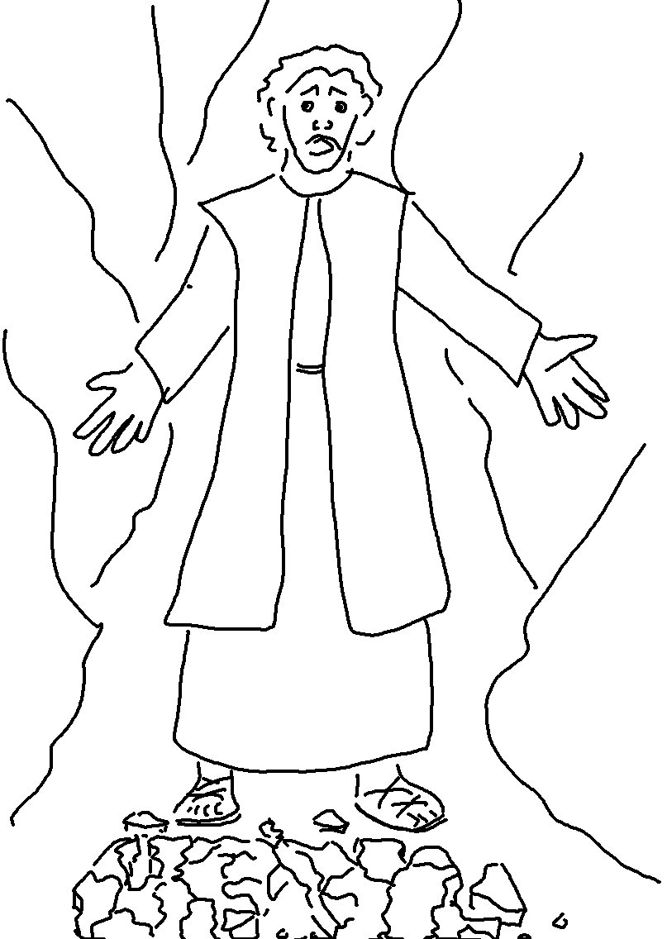
"You must not have any other
god but me."
Exodus 20:3_{NLT}

